aJamhuuriyadda Federaalka Soomaaliya  Ergada Joogtada Soomaliyeed ee Qaramada Midoobey ee Geneva | 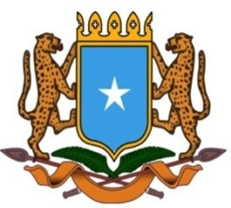 | جمهورية الصوما ل الفيدرالية  البعثة الدائمة لجمهورية الصومال بمكتب الأمم المتحدة بجنيف وبالوكالات المتخصصة بسويسرا

Permanent Mission of the Federal Republic of Somalia to the United Nations Office at Geneva and other International Organizations in Switzerland

Check Against Delivery
Statement by the Delegations of Somalia,
Mr. Abdikadir Mohamed Hussein, First Secretary
at the Review of the Republic of Benin, during the 42th Session of the UPR Working Group on Tuesday, 26 January, 2023 from 9:00AM to 12:30PM, in the Room XX of the Palais des Nations in Geneva, Speaker Number 25, Time: 1 minute and 10 seconds.

Thank you Mr. President,

Somalia extends a warm welcome to the distinguished delegation of Benin to this UPR Working Group, and thanks them for the presentation of their comprehensive national report.

Somalia commends the ratification of several international instruments by the government of Benin including among others, • The Treaty on the Prohibition of Nuclear Weapons, on 11 December 2020 • The Optional Protocol to the Convention on the Elimination of All Forms of Discrimination against Women, on 27 September 2019

This is a clear testimony of the importance attached by the government to improve its legal framework at national et international level with the aim of promoting and protecting the human rights of its citizens.

In a spirit of constructive dialogue, Somalia recommends the following :
y
1. To continue strengthening the status and rights of women by effectively implementing the Sahel Women’s Empowerment and the Demographic Dividend regional initiative for the period 2020-2024 and also by providing sufficient financial resources to the National Women’s Institute.

2. To further enhance efforts aimed at combating acts of corruption and terrorism.

Somalia would like to conclude by wishing to the distinguished delegation of Benin a successful outcome in this review. I Thank you Mr. President.

