aJamhuuriyadda Federaalka Soomaaliya  Ergada Joogtada Soomaliyeed ee Qaramada Midoobey ee Geneva | 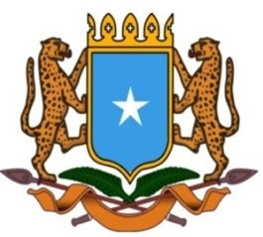 | جمهورية الصوما ل الفيدرالية  البعثة الدائمة لجمهورية الصومال بمكتب الأمم المتحدة بجنيف وبالوكالات المتخصصة بسويسرا

Permanent Mission of the Federal Republic of Somalia to the United Nations Office at Geneva and other International Organizations in Switzerland

Check Against Delivery
Statement by the Delegations of Somalia,
Mr. Hussen Abdi Musa, First Counsellor
at the Review of the Kingdom of Ghana, during the 41th Session of the UPR Working Group on Tuesday, 24 January, 2023 from 2:30PM to 18:00PM, in the Room XX of the Palais des Nations in Geneva, Speaker Number 8, Time: 1 minute and 05 seconds.

Thank you Mr. President,

Somalia warmly welcomes the distinguished delegation of Ghana to this UPR Working Group, and congratulates the presentation of their comprehensive national report.

Somalia applauds the significant efforts made by Ghana in implementing the recommendations received from the previous UPR cycle and the adoption of various legal and institutional measures, including inter alia the adoption of Births and Deaths Registration Act, 2020 (Act 1027), the National Strategic Framework on Ending Child Marriage 2017–2026, as well as the creation of specialized agency under the office of the Attorney General to combat corruption and its related activities.

Somalia encourages the government of Ghana to continue its efforts to improve the situation of human rights in the country and recommends the following :

- To ratify the Convention against Discrimination in Education.

- To ratify the African Union Convention for the Protection and Assistance of Internally Displaced Persons in Africa,

3. to take all necessary measures to amend the Refugee Law, 1992, in order to bring it into conformity with international refugee law and standards.
To conclude, We wish the distinguished delegation of Ghana every success in this review. I Thank you Mr. President.

