aJamhuuriyadda Federaalka Soomaaliya  Ergada Joogtada Soomaliyeed ee Qaramada Midoobey ee Geneva | 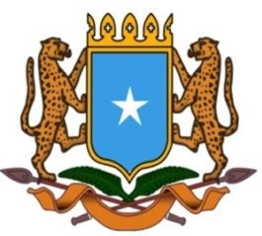 | جمهورية الصوما ل الفيدرالية  البعثة الدائمة لجمهورية الصومال بمكتب الأمم المتحدة بجنيف وبالوكالات المتخصصة بسويسرا

Permanent Mission of the Federal Republic of Somalia to the United Nations Office at Geneva and other International Organizations in Switzerland

Check Against Delivery
Statement by the Delegations of Somalia,
Mr. Hussen Abdi Musa, First Counsellor
at the Review of the Gabonese Republic, during the 42th Session of the UPR Working Group on Tuesday, 24 January, 2023 from 9:00AM to 12:30PM, in the Room XX of the Palais des Nations in Geneva, Speaker Number 8, Time: 1 minute and 10 seconds.

Thank you Mr. President,

Somalia extends a warm welcome to the distinguished delegation of Gabon to this UPR Working Group, and congratulates the presentation of their comprehensive national report.

Somalia highly appreciates the tremendous efforts made by Gabon and the progress achieved, in the promotion and protection of the women and child rights including inter alia, Creation of a toll-free number, for victims of child abuse and for women victims of violence, Gender-based violence unit.

Somalia also commends the support and solidarity extended by the government of Gabon towards long term refugees living in the country by granting them nationality on the basis of one’s willingness and good integration in the society.

Somalia encourages the government of Gabon to continue on this positive strive and offers the following recommendations :

1. To continue implementing the national priorities and initiatives in particular those related to the genuine collaboration of the human rights mechanism at regional and international level, as well as the dissemination of the human rights principles and values within the government institutions and civil society organisations,
2. To further enhance its efforts of combating human trafficking through genuine collaboration with the regional and international organisations involved in this issue.
To conclude, We wish the distinguished delegation of Gabon every success in this review. I Thank you Mr. President.

