Jamhuuriyadda Federaalka Soomaaliya  Ergada Joogtada Soomaliyeed ee Qaramada Midoobey ee Geneva | 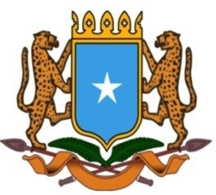 | جمهورية الصوما ل الفيدرالية  البعثة الدائمة لجمهورية الصومال بمكتب الأمم المتحدة بجنيف وبالوكالات المتخصصة بسويسرا

Permanent Mission of the Federal Republic of Somalia to the United Nations Office at Geneva and other International Organizations in Switzerland

Check Against Delivery
Statement by the Delegations of Somalia,
Mr. Abdikadir Mohamed Hussein, First Secretary
at the Review of Pakistan, during the 42th Session of the UPR Working Group on Monday, 30 January, 2023 from 9:00AM to 12:30PM, in the Room XX of the Palais des Nations in Geneva, Speaker Number 50, Time: 00 and 55 seconds.
Thank you Mr. President,

Somalia thanks the delegation of the Islamic Republic of Pakistan for the comprehensive national report and for its constructive engagement with the UPR process.

Somalia commends Pakistan for amending its legislation in response to some of the recommendations of the previous cycle, in particular the provisions that criminalise forced marriage.

In a spirit of constructive dialogue, Somalia recommends the following:

1. Continue efforts to fight unemployment, especially among women, young people and people living in rural areas ;

2. To continue national efforts in preventing and combating all forms of terrorism.

Somalia would like to conclude by wishing to the distinguished delegation of Pakistan a successful outcome in this review. I Thank you Mr. President.

