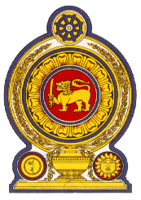

42nd Session of the Universal Periodic Review

Review of Republic of Zambia – 30th January 2023

Statement by the Democratic Socialist Republic of Sri Lanka

Mr. President,

Sri Lanka thanks the delegation of Zambia for the presentation made.

We note the measures taken by Zambia to implement the Convention on the Rights of the Child and the incorporation of the Convention on the Elimination of All Forms of Discrimination against Women into domestic legislation. We also welcome measures taken to address the economic and social sustainable development of the Zambian people and the human rights training given to military and security personnel.

In a constructive spirit, Sri Lanka recommends that Zambia;

- Improve safety and living conditions in prisons, and take all measure to reduce overcrowding in prisons;

2. Continue to develop the health-care system in order to ensure people’s right to health

3. Take further measures for the protection of the rights of the child and to eradicate child labour.

We wish Zambia all the success in its UPR engagement.

