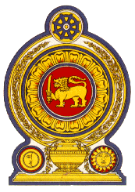

42nd Session of the Universal Periodic Review

Review of Switzerland

25 January 2023

Statement by the Democratic Socialist Republic of Sri Lanka

Mr President,

Sri Lanka welcomes the delegation of Switzerland and the presentation made.

We appreciate Switzerland’s constructive engagement with the UPR process and the progress made following the 3rd UPR cycle.

Sri Lanka commends the progressive policy level and strategic measures taken by Switzerland in the area of human rights including introduction of the Foreign Policy Strategy 2020–2023, Equality Strategy 2030 and National Platform against Poverty 2019– 2024.

In a constructive spirit, Sri Lanka recommends that Switzerland;

- Ratifies the International Convention on the Protection of the Rights of All Migrant Workers and Members of Their Families;

- Further strengthens national efforts at combating trafficking in persons.

We wish Switzerland all the success in its UPR engagement.

