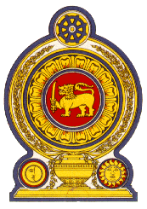

42 Session of the UPR Working Group, 23 January- 3 February 2023

Statement by Sri Lanka on Benin

26 January 2023

Mr. President,

Sri Lanka welcomes the delegation of Benin to this review and appreciates the comprehensive presentation made.

We welcome the establishment of the Benin Human Rights Commission and the enactment of laws and amendments to promote and protect human rights of the people of Benin. We also appreciate Benin’s efforts in curtailing violence against women through the adoption of the National Policy on Gender Equality and amendments introduced to the Personal and Family Code.

In a spirit of constructive dialogue, Sri Lanka recommends that Benin:

- Mobilize efforts and provision of resources to prevent exploitation of children in situations of forced or hazardous labour
- Continue to step up measures to ensure access to drinking water and sanitation
- Intensify efforts to counter human trafficking in particular on child trafficking and provide protection to victims.

Sri Lanka wishes Benin every success in its UPR review.

