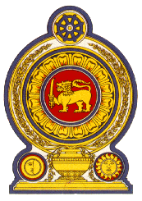

42nd Session of the Universal Periodic Review

Review of Guatemala

25 January 2023

Statement by the Democratic Socialist Republic of Sri Lanka

Mr President,

Sri Lanka thanks the delegation of Guatemala for their presentation.

We appreciate the measures taken by Guatemala since its last UPR in the area of human rights, including new strategies on women and children and on combating gender-based violence.

Sri Lanka welcomes the implementation strategy for the National Plan for the Prevention and Eradication of Violence against Women 2020–2029, introduction of the Comprehensive Support Model for children and adolescents including for women victims of violence.

In a constructive spirit, Sri Lanka recommends that Guatemala;

- Continues to advance the rights of women and their increased participation in public life.

- To enhance legal protection for children.

- To strengthen national efforts at combating trafficking in persons.

We wish Guatemala all the success in its UPR engagement.

