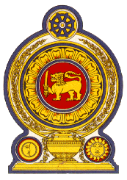

42 Session of the UPR Working Group, 23 January- 3 February 2023

Statement by Sri Lanka on Ghana

24 January 2023

Mr. President,

Sri Lanka welcomes the delegation of Ghana and appreciates the comprehensive presentation made to the Council.

Sri Lanka commends the measures taken by Ghana to advance and uphold human rights of its people including through legislative measures such as the adoption of the Births and Deaths Registration Act, 2020, Enterprises Agency Act, 2020 as well as the Cybersecurity Act, 2020.

We appreciate the continues efforts undertaken by the government of Ghana to improve right to education through initiatives such as the school feeding programme and the passage of the strategic plan of the Domestic Violence and Victims Support Unit of the Ghana Police Service. The adoption of the Righto Information Act, 2019 is also significant We welcome in this regard the establishment of the Right to Information Commission.

In a constructive spirit, Sri Lanka recommends that Ghana:

- Intensify its efforts to improve accessibility for healthcare services and measures to curb neonatal and infant mortality;
- Take appropriate measures to ensure that children have access to education and reduce the gap in enrolment particularly regarding children with disabilities and children from vulnerable segments; and
- Strengthen efforts aimed at eradicating child labour through inclusive national policies and practices.

We wish Ghana every success in its UPR engagement.

