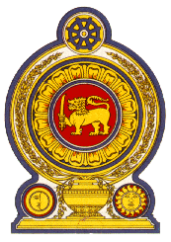

42nd Session of the Universal Periodic Review

Review of Gabon

24 January 2023

Statement by the Democratic Socialist Republic of Sri Lanka

Mr President,

Sri Lanka warmly welcomes the delegation of Gabon and appreciates the presentation made.

We appreciate Gabon’s continued engagement and the progress made following the 3rd UPR cycle.

Introduction of a transparent process to the Gabon Elections Centre is a progressive measure in strengthening democratic system. Sri Lanka further welcomes institutional initiatives and improvements to eliminate violence against women and children. To name a few, introduction of a free call centre to combat various forms of violence against children and a free counselling and guidance contact number for women, opening of a new women’s facility in the Central Prison, introduction of a gender-based violence unit at Akanda police station and establishment of the National Observatory for Women’s Rights.

In a constructive spirit, Sri Lanka recommends that Gabon

- to continue to advance the rights of women including their public participation
- to promote the employment and advancement of women in the economy
- to ensure right to education to all by enhancing access to education.

We wish Gabon success in its UPR engagement.

