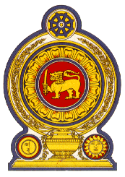

Statement by Sri Lanka
42 Session of the UPR
Review of Czechia – 23 January 2023

Mr. President,

Sri Lanka welcomes the delegation of Czechia and appreciates its presentation of a comprehensive national report as well as its engagement with the HRC today.

We note measures taken by Czechia to promote human rights including the adoption in 2017 of the Strategic Framework Czech Republic 2030, which defines long-term sustainable development priorities for the next decade, the National Strategy for Combating Trafficking in Human Beings 2020-2023, which includes national and international cooperation in combating human trafficking and the National Strategy to Protect Children’s Rights 2021-2029, with the adoption of an action plan for the period 2021-2024 for the implementation of this Strategy.

We take this opportunity to recommend that Czechia :

- Considers ratifying the International Convention on the Protection of the Rights of All Migrant Workers and Members of Their Families.

- Takes measures to further strengthen efforts to prevent and combat trafficking in persons.

- Takes measures for the provision of all persons, including migrants, with access to health services, regardless of legal status and documentation.

Finally, we wish Czechia success in its UPR engagement.

Thank you.

