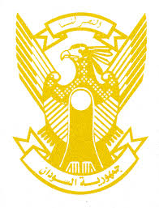
Sudan’s Statement on the Czech Republic Universal Periodic Review during 42nd UPR Working Group
Delivered by
H.E Ambassador Hassan Hamid Hassan Permanent Representative of
the Republic of the Sudan,
23 January 2023
ــــــــــــــــــــــــــــــــــــــــــــــــــــــــــــــــــــــــــــــــــــــــــــــــــــــــــــــــــــــــــــــــــــــــــــ

Thank you, Excellency,
Sudan welcomes the distinguished delegation of the Czech Republic and thank them for their report.
Sudan appreciates the positive steps taken by the Czech Republic in the context of promotion and protection of human rights including establishing Government Human Rights Council, adopting its national strategy to protect children’s rights, long term strategic framework on sustainable development, action plan for business and human rights and its support to the OHCHR.
Sudan recommends the Czech Republic to continue its efforts aimed at combating discrimination and hate crime and protecting migrants and refugees.
We wish the Czech Republic all success and continuous progress.

