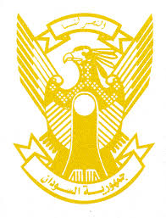
Sudan’s Statement on Argentina’s Universal Periodic Review during 42nd UPR Working Group
Delivered by
H.E Ambassador Hassan Hamid Hassan Permanent Representative of the Republic of the Sudan
23 January 2023
ــــــــــــــــــــــــــــــــــــــــــــــــــــــــــــــــــــــــــــــــــــــــــــــــــــــــــــــــــــــــــــــــــــــــــــ
Thank you, Excellency,

Sudan welcomes Argentinian delegation and thank them for their report.
We appreciate the positive efforts taken by Argentina since last UPR including establishing ministry for women, gender and diversity, establishing its national committee for the prevention of torture, adopting its national plan against Discrimination (2021-2024), adopting rights-based approach in response to Covid-19 pandemic and engaging positively and actively with regional and international human rights mechanisms including this council.
Sudan recommends Argentina to continue its efforts aimed at achievement of SDGs including provision of social services, enhance poverty eradication actions especially in rural areas.
We wish to Argentina all success and continuous progress.

