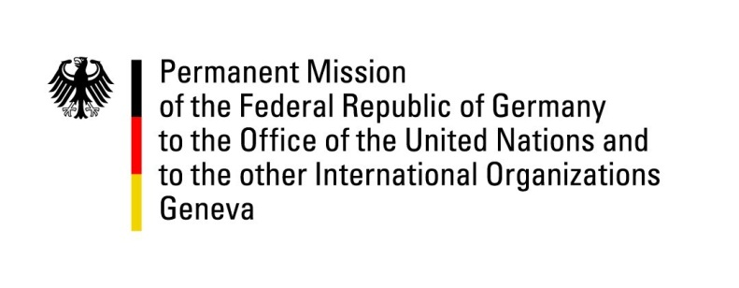

United Nations Human Rights Council

42nd Session of the UPR Working Group

Geneva, 31st of January 2022

German Recommendations and advance questions to

Japan

Madam Vice-President,
Germany welcomes the delegation of Japan. We commend Japan for setting out to comply with the Paris Principles by creating the office of a special advisor to the Prime Minister on human rights issues, as well as for initiating a reform of the existing family law.

Germany remains concerned about the continued application of the death penalty.

Germany therefore recommends to:
- Enact an immediate formal moratorium on capital punishment. Ratify the Second Optional Protocol to the International Covenant on Civil and Political Rights to abolish the death penalty.
- Introduce minimum standards of conduct during detention to end abusive practices by applying the Mandela Rules.
- Speed up the implementation of 2020’s basic plan for gender equality to improve women’s participation in all fields while securing their equal access to education, job positions and public office.
- Prevent discrimination against members of the LGBTQI community.
Thank you, Madam Vice- President.

