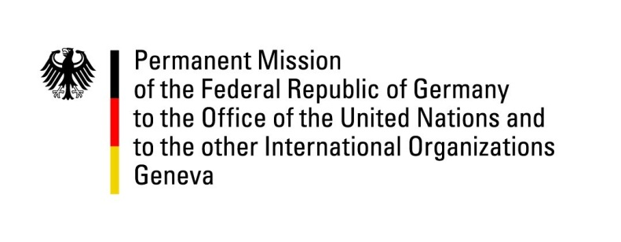

United Nations Human Rights Council

42nd Session of the UPR Working Group

Geneva, 30th January 2023

German Recommendations to

Zambia

Mister Vice-President,
Germany welcomes the delegation of Zambia and commends Zambia’s efforts in implementing last cycle’s recommendations, in particular regarding the abolition of the death penalty. Moreover, Germany commends the progress made in the implementation of human rights of children through the adoption of the Child Code Act and the right to education.

However, Germany remains concerned about the freedom of expression and assembly, the protection from torture and the efficiency of the judiciary and criminal law. Germany underlines the open potential for better protection of minorities, including women and girls.

Germany therefore has 4 recommendations:
- Develop strategies to promote equal rights of women and girls, e.g. by finalizing the review of the “Anti-Gender Based Violence Act” and by adapting the Zambian electoral law.
- Accelerate and finalize the revision of the “Public Order Act” and the “Cyber Security and Cyber Crimes Act” to better protect the freedom of expression online and offline.
- Rapidly adopt and implement the “Anti-Torture Bill”.
- Swiftly finalize the revision of the criminal including criminal proceedings law and thus improve living conditions in Zambia’s prisons.

Thank you, Mister Vice-President.

GERMAN ADVANCE QUESTIONS TO ZAMBIA:
- What steps is Zambia undertaking in order to promote equal rights of women and their political participation and to safeguard women and girls from gender-based violence?
- What is the current status of the revision of the “Public Order Act” and of the “Cyber Security and Cyber Crimes Act” and when will it be finalized?
- When will the respective legislature procedure of the “Anti Torture Bill” start in Parliament?
- What is the current status of the revision of the criminal law and criminal proceedings law and when will it be finalized?

