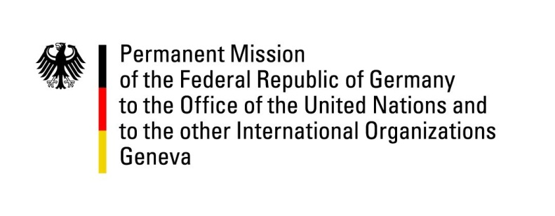

United Nations Human Rights Council

42nd Session of the UPR Working Group

Geneva, 30th of January 2023

German Recommendations and advance questions to

The Islamic Republic of Pakistan

Mister President,
Germany welcomes the delegation of the Islamic Republic of Pakistan. We welcome that the Islamic Republic has not carried out any death sentences since 2019. We also appreciate that two criminal offenses are not punishable by death anymore and encourage further steps in this regard.

However, Germany remains deeply concerned about the blasphemy legislation in Pakistan, its increasing application, and impunity of false blasphemy accusations.
Moreover, enforced disappearance and prevailing impunity in this regard remain pressing and worrisome human rights concerns. As is the lacking legislation regarding underage marriage, which disproportionately affects young girls.

Germany therefore recommends to:

- Apply and implement effectively existing legislative protections against blasphemy laws.
- Implement nation-wide legislation regulating a minimum age for marriage
- Declare a new moratorium on the death penalty or extend the current one and decrease further the number of criminal offenses punishable by death.
- Investigate and prosecute all cases of enforced disappearance.

Thank you, Mister President.

