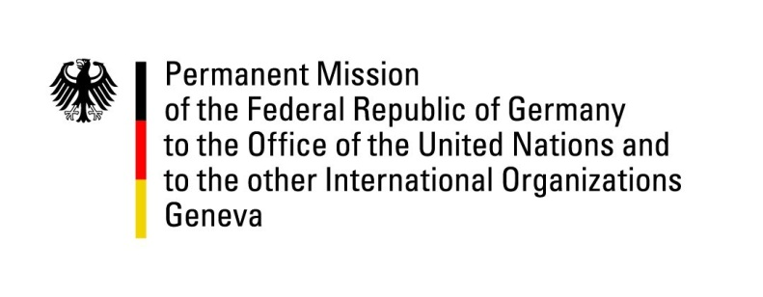

United Nations Human Rights Council

42nd Session of the UPR Working Group

Geneva, 26th of January 2022

German Recommendations and advance questions to

Benin

Mister President,
Germany welcomes the delegation of Benin and commends the country for the creation of its Human Rights Commission, the abolition of the death penalty, the ratification of essential international conventions, like CEDAW, and the adoption of several laws improving the protection of human rights of women.

Germany remains concerned about the freedom of press, the efficiency and independence of the judiciary, conditions in prisons and the length of pre-trial custodies. Safeguarding free press as well as strengthening democratic principles and the rule of law are the foundation for long-term societal and economic prosperity.

Germany recommends to:
- Eliminate restrictions of the freedom of the press by recanting the „Code du numérique“, Benin’s media law.
- Implement efficient judicial procedures ensuring independence of the judiciary.
- Curb the length of pre-trial custodies and improve conditions for inmates in existing prison facilities.
- Ensure that laws advancing rights protection of women can be adequately implemented by increasing the budget for human resources, including education and training.

Thank you, Mister President.

