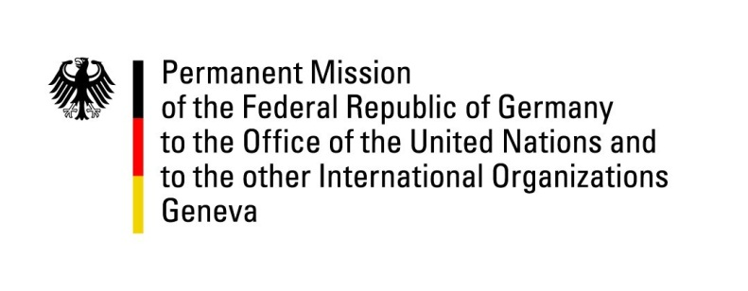

United Nations Human Rights Council

42nd Session of the UPR Working Group

Geneva, 25th January 2023

German Recommendations to

Guatemala

Mister President,
Germany welcomes the delegation of Guatemala to the 4th UPR cycle. We commend Guatemala’s efforts in implementing last cycle’s recommendations.

Germany remains concerned about growing political pressure on the independence of the judiciary and the situation with regards to freedom of expression and freedom of the press.
Germany recommends to:
- Strengthen the rule of law and the independence of the judiciary
- Strengthen the work of civil society by implementing public policies to protect it against repression, political pressure and abuse of violence
- Create safe spaces for dialogue between state authorities, indigenous peoples and organized civil society
- Increase funding and political support for government human rights institutions and programmers, including the Presidential Commission on Human Rights, the Human Rights Ombudsman’s Office and the National Reparation Programmes
Thank you, Mister President.

