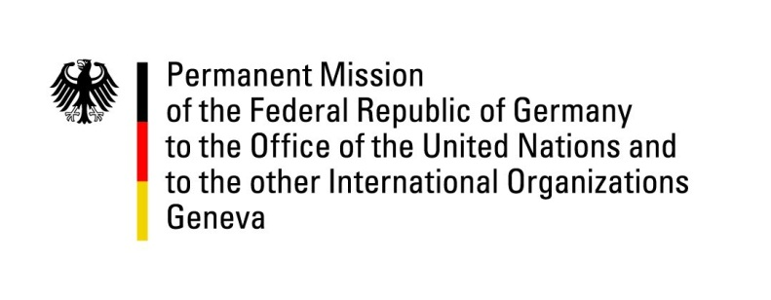

United Nations Human Rights Council

42nd Session of the UPR Working Group

Geneva, 25th of January 2023

German Recommendations to

The Republic of Peru

Mister President,
Germany welcomes the delegation of the Republic of Peru. We appreciate Peru’s development of various detailed national action plans concerning human rights, as well as the ratification of several international agreements, such as the Domestic Workers Convention.
Germany remains concerned about the rights of indigenous peoples, women, and LGBTIQ+ persons.
We are also very concerned about the casualties during recent protests.
Germany therefore recommends to:
- Train police and military forces in de-escalation strategies and crowd control, in order to prevent violent deaths of protesters.
- Ratify the Escazú Agreement, and guarantee prior consultations for projects extracting resources from indigenous lands. Also, introduce a Peru-wide cadastre in order to enable indigenous peoples to have documented ownership of their land.
- Concerning the protection of women's and girls' lives and dignity, increase the minimum marriage age to prevent child marriage and preserve the right of women to decide over their own fate by preventing a total ban on abortions, as demanded by certain political forces.
- Regarding violence against women and LGBTIQ+ people, sensitize public servants to their human rights, particularly in the judiciary. Also, we recommend to establish rights-based, non-discriminatory sex education in educational institutions.
Thank you, Mister President.

