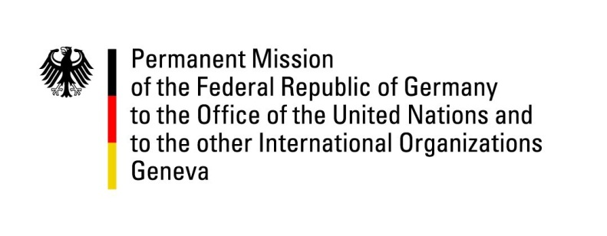

United Nations Human Rights Council

42nd Session of the UPR Working Group

Geneva, 24. of January 2023

German Recommendations and advance questions to

Ghana

Mister President,
Germany welcomes the delegation of Ghana.
Germany commends Ghana for recent actions of the Office of the Special Prosecutor to combat corruption and corruption-related offences. These contributed to restoring confidence of citizens into the capability of this office to effectively executing its mandate.

Germany remains concerned about the human rights situation of children, LGBTQI+ persons and journalists.

Germany recommends to:
- Implement safeguarding mechanisms to ensure that child labour is reduced and eventually eradicated.
- Combat violence and discrimination of LGBTQI+ persons and ensure that criminal acts against them are effectively investigated, prosecuted and sanctioned, including through police and judiciary trainings and awareness-raising.
- Ensure that state security agents and officials put a stop to attacks, arrests and intimidation of people, especially journalists, in order to safeguard free press as well as the freedom of expression.

Thank you, Mister President.

