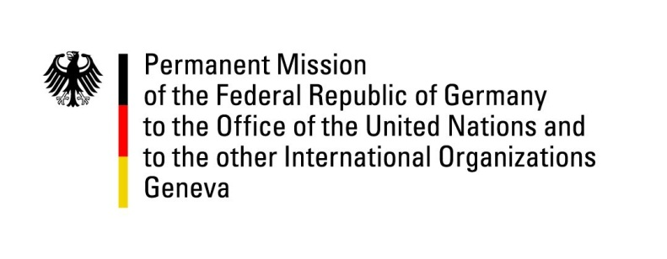

United Nations Human Rights Council

42nd Session of the UPR Working Group

Geneva, 23rd of January 2023

German Recommendations

the Argentine Republic

Mister President,
Germany welcomes the delegation of the Argentine Republic.

Germany commends the Argentine Republic for strengthening the rights of women and LGBTIQ+ people through progressive legislation and a stronger institutional framework, in line with German recommendations from the last UPR cycle.

Germany is concerned about attempts of exercising political influence on the justice system. We are concerned about the situation of indigenous people and police violence.

Germany therefore recommends to:
- Strengthen the independence of the judiciary, protect judges and investigators from pressure and intimidation
- Work with the political opposition to fill the vacant posts of the Attorney General, the Supreme Court judge and the Ombudsman.
- Complete the land surveys on indigenous territories as provided for in Law 26.160 .
- Take measures to prevent and deter excessive state and police violence, and to raise awareness among police and prison forces.

Thank you, Mister President.

