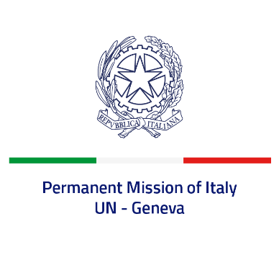
Check against delivery
UPR 42 - Sri Lanka
Wednesday 1 February 2023, 9:00 - 14:30

(Focal point: Angela Zanca, First Secretary)

Thank you, Mister President.

We thank the distinguished delegation of Sri Lanka for the presentation.

Italy appreciates Sri Lanka’s support to the UN Resolution for a moratorium on the use of death penalty and welcomes the adoption of the first National Action Plan on Women, Peace and Security last December.

Italy seizes this opportunity to offer Sri Lanka the following recommendations:

- Consider adopting a de jure moratorium on capital executions;
- Take concrete steps to combat any form of discrimination in law and practice against persons belonging to religious minorities and promote inter-faith dialogue;
- Guarantee freedoms of expression, peaceful assembly and association, and ensure a safe environment for civil society, including human rights defenders and journalists;
- End all forms of violence and discrimination against women, including domestic violence and child, early and forced marriage;
- Prevent and combat all forms of torture, enforced disappearances, arbitrary detention and ensure accountability for human rights violations and abuses.

We wish Sri Lanka a successful review.

I thank you.

