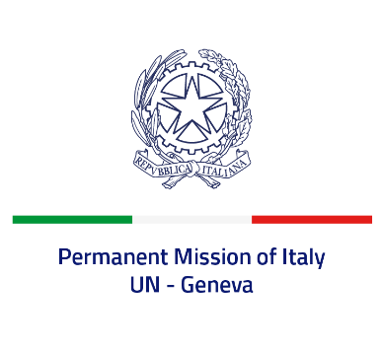
Check against delivery
UPR 42 - Zambia
Monday 30 January 2023, 14:30 - 18:00

(Focal point: Angela Zanca, First Secretary)

Thank you, Mister President.

We thank the distinguished delegation of Zambia for the presentation.

Italy commends Zambia for achieving significant progress toward the abolition of death penalty and supports its efforts to amend the Penal Code and the Criminal Procedure Code accordingly.

We also recognize the measures taken by Zambia to improve access to education and to protect children’s rights, including through the adoption of the Children’s Code Act in 2022 and especially its provisions to end child, early and forced marriage.

Italy seizes this opportunity to offer Zambia the following recommendations:

- Ratify the Second Optional Protocol to the International Covenant on Civil and Political Rights, and consider voting in favour of the UN Resolution for a moratorium on the use of death penalty;
- Continue to strengthen efforts to protect and promote the rights of women and children, including by preventing and combating all forms of violence and abuse against them;
- Take further steps to ensure freedom of opinion and expression and media freedom.

We wish Zambia a successful review.

I thank you.

