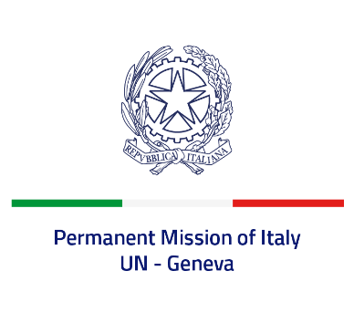
Check against delivery
UPR 42 – Pakistan
Monday 30 January 2023, 9:00 – 12:30
Delivered by: Deputy Permanent Representative of Italy Marie Sol Fulci

(Focal point: Daniele Borrelli, First Counsellor)

Thank you, Mister President.

We thank the distinguished delegation of Pakistan for their national report and presentation.

Italy welcomes the measures to enhance human rights, including the rights of women and children, as well as the recent adoption of an anti-torture law.

Italy would like to recommend to:

- Sign and ratify the International Convention for the Protection of all Persons from Enforced Disappearance;
- Consider re-establishing a moratorium on imposing and carrying out the death penalty, as a step towards its complete abolition;
- Strengthen efforts to prevent and respond to any form of discrimination against persons belonging to religious minorities, with special regard to women, girls, and children;
- Consider decriminalizing blasphemy;
- Continue efforts to end child, early and forced marriages, as well as all forms of violence and discrimination against women and girls.

We wish the delegation of Pakistan a successful review.

I thank you.

