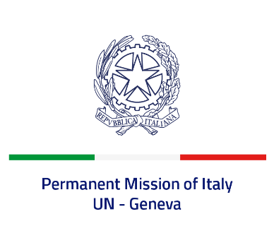

*Check against delivery*

**UPR 42 – Republic of Korea**

**Thursday 26 January 2023, 14:30 – 18:00**

**Delivered by: Ambassador Gian Lorenzo Cornado, Permanent Representative of Italy**

*(Focal point: Daniele Borrelli, First Counsellor)*

Thank you, Mister President.

We thank the distinguished delegation of the Republic of Korea for their national report and presentation.

Italy welcomes the efforts to eliminate discrimination against women, promote gender equality and enhance female representation in the public sector, including through the second *Gender Equality Basic Plan (2018-2022)*. We also welcome the support of the Republic of Korea to the last UN General Assembly’s Resolutions on a moratorium on the use of death penalty.

Italy seizes this opportunity to offer the Republic of Korea the following recommendations:

* *Consider adopting a de iure moratorium on capital executions;*
* *Ratify the Optional Protocol to the Convention against Torture and Other Cruel, Inhuman or Degrading Treatment or Punishment*
* *Intensify efforts to promote women’s rights and to prevent and combat all forms of discrimination and violence against them, both online and offline;*

We wish the delegation of the Republic of Korea a successful review.

I thank you.