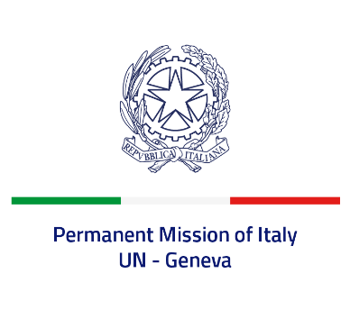
Check against delivery
UPR 42 – Guatemala
Wednesday 25 January 2023, 14:30 – 18:00
Delivered by: Ambassador Gian Lorenzo Cornado, Permanent Representative of Italy

(Focal point: Daniele Borrelli, First Counsellor)
Thank you, Mister President.

We thank the distinguished delegation of Guatemala for their national report and presentation.

Italy welcomes the efforts to combat violence against women and girls, including through the reactivation of the National Coordination Office for the Prevention of Domestic Violence and Violence against Women and the updated implementation strategy for the National Plan for the Prevention and Eradication of Violence against Women 2020–2029. Italy also welcomes Decree No. 13-2017 amending the Civil Code to set the minimum age for marriage or entering into a union at 18 years of age for women and men.

Italy seizes this opportunity to offer Guatemala the following recommendations:

- Ensure a safe and enabling environment for freedom of expression and media freedom, and safeguard the activities of human rights defenders and journalists including by introducing national laws and policies to protect them;
- Ensure the respect of the rule of law, including the independence of the judiciary;
- Consider taking steps with a view to fully abolishing the death penalty;
- Continue implementing reforms to prevent and combat all forms of discrimination and violence against women and ensure accountability and adequate assistance to women and girls victims of violence;
We wish the delegation of Guatemala a successful review. I thank you.

