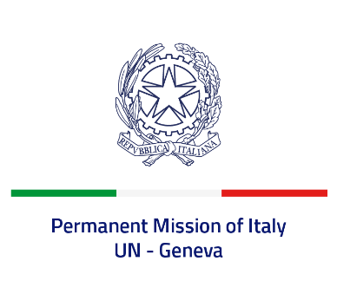
Check against delivery
UPR 42 - Peru
Wednesday 25 January 2023, 9:00 - 12:30

Delivered by: Ambassador Gian Lorenzo Cornado, Permanent Representative of Italy

(Focal point: Angela Zanca, First Secretary)

Thank you, Mister President.

We thank the distinguished delegation of Peru for the presentation.

Italy takes note of the steps undertaken by Peru during the period under review in order to address sexual violence against women, to combat negative stereotypes, and to fight against trafficking in persons, as recorded by the UN Country Team.

Italy seizes this opportunity to offer Peru the following recommendations:

- Consider abolishing the death penalty for all crimes;
- Strengthen efforts to combat all forms of criminal organizations, prevent and combat drug and human trafficking;
- Ensure freedom of expression and peaceful assembly, and create a safe environment for civil society, including human rights defenders;
- Ensure a proportionate use of the force from the security forces;
- Strengthen efforts to prevent and combat all forms of discriminations against persons in most vulnerable situations, including women, young persons and persons living in rural communities;
- Ensure accountability for human rights violations and provide adequate assistance to victims of violence and abuses.

We wish Peru a successful review.

I thank you.

