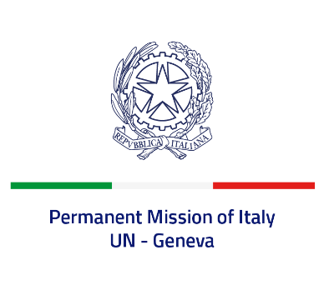
Check against delivery
UPR 42 – Ghana
Tuesday 24 January 2023, 14:30 – 18:00
Delivered by: Ambassador Gian Lorenzo Cornado, Permanent Representative of Italy

(Focal point: Daniele Borrelli, First Counsellor)
Thank you, Mister President.

We thank the distinguished delegation of Ghana for their national report and presentation.

Italy commends Ghana for its continued efforts to enhance human rights and welcomes the long-standing de facto moratorium on the death penalty and its support to the 2022 UNGA Resolution for a moratorium on the use of death penalty.

Italy seizes this opportunity to offer Ghana the following recommendations:

- Consider adopting a de iure moratorium on death penalty.
- Continue ensuring freedom of expression and media freedom and pluralism and strengthen the safety of journalists by amending the respective legislation to comply with international standards.
- Step up efforts to combat all forms of violence and discrimination against women and girls, including domestic violence;
- Strengthen efforts to implement the legal framework prohibiting child labour;
- Continue to improve the legal framework on the rights of persons with disabilities, in line with the provisions of international conventions.
We wish the delegation of Ghana a successful review.

I thank you.

