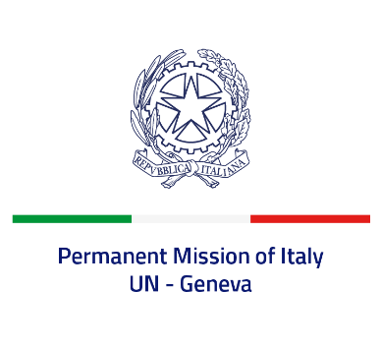
Check against delivery
UPR 42 - Gabon
Tuesday 24 January 2023, 9:00 - 12:30

Delivered by: Ambassador Gian Lorenzo Cornado, Permanent Representative of Italy

(Focal point: Angela Zanca, First Secretary)

Thank you, Mister President.

We thank the distinguished delegation of Gabon for the presentation.

Italy welcomes the legislation adopted in September 2021 aimed at enhancing women’s rights and gender equality, as well as to eliminate all forms of violence and discrimination against women and girls.

We also commend Gabon for decriminalizing consensual adult same sex relations.

Italy seizes this opportunity to offer Gabon the following recommendations:

- Ratify the Optional Protocol to the International Covenant on Civil and Political Rights;
- Take concrete measures to ensure the full exercise of the right to freedom of expression, association and peaceful assembly, and promote a safe environment for civil society;
- Advance the fight against trafficking in human beings, especially in women and children;
- Step up efforts to ensure protection of the rights of all detained persons and improve the conditions of detention;
- Spread the knowledge about the texts of the legislation in favour of women and girls to the general public to ensure effective gender equality.

We wish Gabon a successful review.

I thank you.

