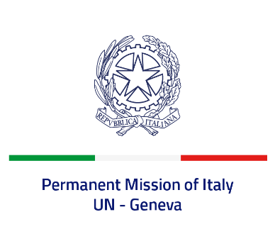
Check against delivery
UPR 42 - Argentina
Monday 23 January 2023, 14:30 - 18:00

Delivered by: Ambassador Gian Lorenzo Cornado, Permanent Representative of Italy

(Focal point: Angela Zanca, First Secretary)

Thank you, Mister President.

We thank the distinguished delegation of Argentina for the presentation.

Italy praises Argentina for its commitment to protect and enhance women’s rights, including through national public policies on gender equality. In this regard, we welcome the adoption of the new National Action Plan for Combating Gender-Based Violence 2022-2024.

Italy seizes this opportunity to offer Argentina the following recommendations:

- Continue efforts to promote the rights of indigenous peoples, including with reference to land property and consultative mechanisms;
- Continue efforts to improve penitentiary system conditions and to reduce episodes of violence in prison;
- Continue efforts to prevent and combat discrimination and violence against women.

We wish Argentina a successful review.

I thank you.

