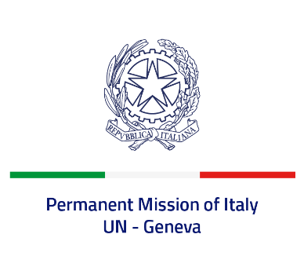
Check against delivery
UPR 42 – Czechia
Monday 23 January 2023, 9:00 – 12:30
Delivered by: Ambassador Gian Lorenzo Cornado, Permanent Representative of Italy

(Focal point: Daniele Borrelli, First Counsellor)
Thank you, Mister President.

We thank the distinguished delegation of Czechia for their national report and presentation.

Italy commends Czechia for its commitment to promoting and protecting human rights and its dedication to the work of the Human Rights Council, demonstrated also by the election of Amb. Václav Bálek as President of this body for the year 2023.

Italy appreciates the efforts of the Czech authorities to meet the huge challenge of hosting over 400.000 refugees from Ukraine and the particular attention given to the needs of Ukrainian children, providing them with access to education in their native language.

Italy seizes this opportunity to offer Czechia the following recommendations:

- Sign and ratify the Optional Protocol to the International Covenant on Economic, Social and Cultural Rights
- Continue efforts to promote women’s rights and ratify the Council of Europe Convention on preventing and combating violence against women and domestic violence (Istanbul Convention)
We wish the delegation of Czechia a successful review.

I thank you.

