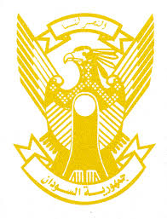
Sudan’s Statement on Switzerland’s Universal Periodic Review during 42nd UPR Working Group
Delivered by
H.E Ambassador Hassan Hamid Hassan, Permanent Representative of the Republic of the Sudan
27 January 2023
ــــــــــــــــــــــــــــــــــــــــــــــــــــــــــــــــــــــــــــــــــــــــــــــــــــــــــــــــــــــــــــــــــــــــــــ
Thank you, Excellency,
Sudan welcomes the honorable delegation of the Swiss Confederation led by State Secretary Ms. Livia Leu.
Sudan positively notes the progress made by Switzerland since its last review including establishing its National Human Rights Institute and taking effective measures to combat human trafficking.
In the spirit of the constructive dialogue, we recommend the following:
- Continue its considerable efforts aimed at protecting migrants, refugees and minorities.
- Continue its considerable efforts to strengthen its human rights’ legislative, institutional frameworks.
We wish Switzerland a successful UPR.

