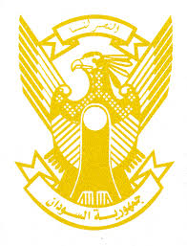
Sudan’s Statement on Republic of Korea’s Universal Periodic Review during 42nd UPR Working Group
Delivered by
Mr. Omar Shareef Hamad Eisa,
First Secretary ,Permanent Mission of the Republic of the Sudan
26 January 2023
ــــــــــــــــــــــــــــــــــــــــــــــــــــــــــــــــــــــــــــــــــــــــــــــــــــــــــــــــــــــــــــــــــــــــــــ
Thank you, Excellency,
Sudan welcomes the delegation of the Republic of Korea and thank them for their presentation.
We commend the progress made by Republic of Korea since its last review including adopting National Action Plan for the Promotion and Protection of Human Rights, passing the Act on the Prevention of Human Trafficking and Protection of Victims, Framework Act on Prevention of Violence against Women and National Inclusive Children Policy.
In the spirit of the constructive dialogue, we recommend the following:
- continue its efforts in ensuring protection for women, girls against all kind of violence, harassment and abuses.
- Continue its efforts to protect employees from abuses at workplaces.
We wish Republic of Korea a successful UPR.

