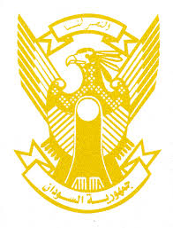
Sudan’s Statement on Sri Lanka’s Universal Periodic Review during 42nd UPR Working Group
Delivered by
Mr. Omar Shareef Hamad Eisa,
First Secretary, Permanent Mission of the Republic of the Sudan
1 February 2023
ــــــــــــــــــــــــــــــــــــــــــــــــــــــــــــــــــــــــــــــــــــــــــــــــــــــــــــــــــــــــــــــــــــــــــــ
Thank you, Excellency,
Sudan welcomes the honorable delegation of Sri Lanka and thank them for their comprehensive presentation.
We commend the progress made by Sri Lanka since its last review including enhancing its human rights’ legislative framework, undertaking effective measures to promote human rights education and engaging positively with international human rights mechanisms.
In the spirit of the constructive dialogue, we recommend the following:
- Intensify peace building and social reconciliation efforts.
- Strengthen its efforts aimed at achieving SDGs including expanding access to health, education and drinking water and continue the endeavors to improve livelihoods.
We wish Sri Lanka all success and continued progress.

