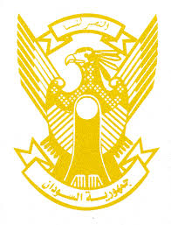
Sudan’s Statement on Pakistan’s Universal Periodic Review during 42nd UPR Working Group
Delivered by
H.E Ambassador Hassan Hamid Hassan Permanent Representative of the Republic of the Sudan
30 January 2023
ــــــــــــــــــــــــــــــــــــــــــــــــــــــــــــــــــــــــــــــــــــــــــــــــــــــــــــــــــــــــــــــــــــــــــــ
Thank you, Excellency,
Sudan welcomes the honorable delegation of Pakistan and thank them for their comprehensive presentation.
We commend the positive steps taken by Pakistan since its last UPR including enacting its Juvenile Justice System Act, Protection of Journalist and Media Professional Act, establishment of National Commission of the Rights of Childs.
In the spirit of constructive engagement, we recommend Pakistan to:
- Continue its policy in ensuring protection and support to refugees.
- Continue its efforts to foster national policies and programs aimed at achieving SDGs.

We wish Pakistan all success and continued progress.

