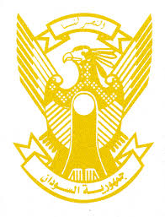
Sudan’s Statement on Zambia’s Universal Periodic Review during 42nd UPR Working Group
Delivered by
H.E Ambassador Hassan Hamid Hassan, Permanent Representative of the Republic of the Sudan
30 January 2023
ــــــــــــــــــــــــــــــــــــــــــــــــــــــــــــــــــــــــــــــــــــــــــــــــــــــــــــــــــــــــــــــــــــــــــــ
Thank you, Excellency,
Sudan welcomes the honorable delegation of Zambia and thank them for their presentation.
We commend the progress made by Zambia since its last review including adopting its Eighth National Development Plan 2022-2026, inclusion of human rights’ education in school curriculum and inclusion of Mandela Rule in its correctional legislative and policy frameworks.
In the spirit of the constructive dialogue, we recommend the following:
- Ratify the Convention against Discrimination in Education.
- Fostering its efforts aimed at achieving SDGs including expanding access to health, education and drinking water.

We wish Zambia a successful cycle of review.

