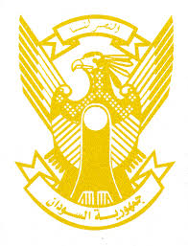
Sudan’s Statement on Benin’s Universal Periodic Review during 42nd UPR Working Group
Delivered by
Mr. Omar Shareef Hamad Eisa,
First Secretary, Permanent Mission of the Republic of the Sudan, Geneva
26 January 2023
ــــــــــــــــــــــــــــــــــــــــــــــــــــــــــــــــــــــــــــــــــــــــــــــــــــــــــــــــــــــــــــــــــــــــــــ
Thank you, Excellency,
Sudan welcomes delegation of the Republic of Benin and thank them for their presentation.
We commend the progress made by Benin since its last review including establishing National Human Rights Commission, adopting National Development Plan (2018-2025), Action Plan for the Implementation of National Child Protection Policy 2021-2015, passing its act on modernization of justice system in 2020, establishing its National Women’s Institute.
In the spirit of constructive dialogue, we recommend the Republic of Benin to:
- continue its efforts aimed at strengthening human rights’ legislative, institutional and policy frameworks.
- Continue its efforts to realize social and economic development and alleviate poverty.
We wish Benin all success and continuous progress.

