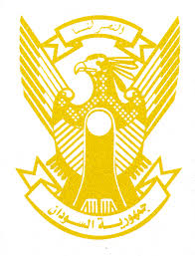
Sudan’s Statement on Ghana’s Universal Periodic Review during 42nd UPR Working Group
Delivered by
H.E Ambassador Hassan Hamid Hassan, Permanent Representative of the Republic of the Sudan
24 January 2023
ــــــــــــــــــــــــــــــــــــــــــــــــــــــــــــــــــــــــــــــــــــــــــــــــــــــــــــــــــــــــــــــــــــــــــــ
Thank you, Excellency,
Sudan welcomes the delegation of the Republic of Ghana and thank them for their presentation.
We commend the progress made by Ghana since its last review including enhancing the human rights’ legislative framework through enacting new laws such as witness protection, rights to information acts.
In the spirit of the constructive dialogue, we recommend the following:
- continue its efforts to strengthen human rights’ legislative, institutional and policy frameworks.
- Strengthen its efforts aimed at achieving SDGs including expanding access to health, education and drinking water and continue the endeavors to improve livelihoods, eradicate poverty and support small and medium enterprises.
We wish Ghana success UPR.

