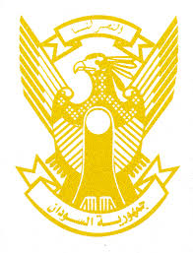
Sudan’s Statement on Gabon’s Fourth Universal Periodic Review during 42nd UPR Working Group
Delivered by
H.E Ambassador Hassan Hamid Hassan, Permanent Representative of the Republic of the Sudan
24 January 2023
ــــــــــــــــــــــــــــــــــــــــــــــــــــــــــــــــــــــــــــــــــــــــــــــــــــــــــــــــــــــــــــــــــــــــــــ
Thank you, Excellency,
Sudan welcomes delegation of Gabon and thank them for their comprehensive report.
We applaud the progress made by Gabon since its last review process including legal and institutional reform, adoption of strategy to promote women’s rights and reduce gender inequality, conduction of the national elections and initiating and facilitating national dialogue.
In the spirit of constructive dialogue, we recommend the Republic of Gabon to:
- continue efforts aimed at strengthening human rights’ legislative and institutional frameworks.
- Continue efforts to strengthen national policies and programs aimed at achieving SDGs.
We wish Gabon all success and continuous progress.

