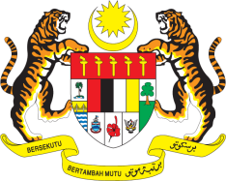

STATEMENT BY MALAYSIA
REVIEW OF SRI LANKA
42ND SESSION OF THE UPR WORKING GROUP
23 JANUARY – 3 FEBRUARY 2023

Malaysia commends Sri Lanka for its commitment to promote and protect human rights despite facing various challenges in the country. We welcome Sri Lanka’s efforts to educate the public on policies and legislation relating to the rights of women and children and to prevent drug abuse, child abuse and human trafficking.

- In the spirit of constructive engagement, Malaysia recommends the following:

2.1 Continue its efforts to provide efficient social protection to low-income households and vulnerable groups as well as equal access to quality education for all children;

2.2 Step up efforts to enhance participation by women in political and public life;

2.3 With assistance from OHCHR, institutionalize a focal point Ministry as the National Mechanisms for Reporting and Follow-up (NMRF) as a domestic mechanism to coordinate the implementation of the UPR; and

2.4 Ensure impartial and effective investigations into attacks against minorities and strengthen policies that further protect their rights.

- We wish Sri Lanka a successful review.

Thank you.

1 FEBRUARY 2023
GENEVA

