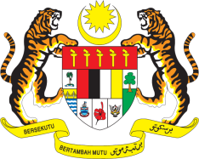

STATEMENT BY MALAYSIA
REVIEW OF JAPAN
42ND SESSION OF THE UPR WORKING GROUP
23 JANUARY – 3 FEBRUARY 2023

Malaysia welcomes Japan’s commitment to promote development cooperation and its contribution to advance the implementation of economic, social and cultural rights in many parts of the developing world.

- In the spirit of constructive engagement, Malaysia recommends the following:

3.1 Address pressing population issues and demographic transitions including a declining fertility rate, an aging population, and urbanisation, through a human rights based approach;

3.2 Strengthen legislation to combat the sexual and criminal exploitation of children;

3.3 Ensure that future responses to the COVID-19 pandemic or other public health emergencies does not discriminate against ethnic minorities or other marginalised groups; and

3.4 Continue to focus on the promotion of SDGs in its international engagements, especially those related to economic, social and cultural rights.

- We wish Japan a successful review.

Thank you.

31 JANUARY 2023
GENEVA

