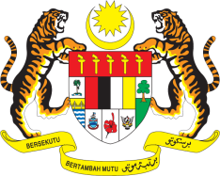

STATEMENT BY MALAYSIA
REVIEW OF ZAMBIA
42ND SESSION OF THE UPR WORKING GROUP
23 JANUARY – 3 FEBRUARY 2023

Malaysia welcomes Zambia’s commitments to implement the UPR recommendations including by adopting the National Human Rights Action Plan. We encourage Zambia to include economic, social and cultural rights in its Constitution with the aim to protect vulnerable groups such as women, children and persons with disabilities.

- In the spirit of constructive engagement, Malaysia recommends the following:

3.1 Intensify efforts to address social and economic challenges including through increasing budgetary allocations to promote sustainable access to safe drinking water;

3.2 Improve access and strengthen the quality of education through sustained investment in the education sector; and

3.3 Strengthen the institutional framework on environment and resource management to conserve natural resources, reduce the risks of food insecurity and hunger, as well as to ensure sustainable development.

- We wish Zambia a successful review.

Thank you.

30 JANUARY 2023
GENEVA

