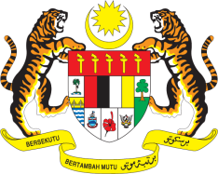

STATEMENT BY MALAYSIA
REVIEW OF PAKISTAN
42ND SESSION OF THE UPR WORKING GROUP
23 JANUARY – 3 FEBRUARY 2023

Malaysia commends Pakistan for its efforts to promote and protect human rights of its people. We are encouraged by its commitment to provide human rights protections for all, including those in marginalised and vulnerable settings.

- In the spirit of constructive engagement, Malaysia recommends the following:

3.1 Continue to implement legislation to protect women and girls from gender-
based violence, in line with international human rights law and standards;

3.2 Continue its efforts to reduce the rate of neonatal and maternal mortality;

3.3 Undertake more efforts to ensure that all children enjoy the right to education and have equal access to quality primary and secondary education, in particular girls living in rural areas; and

3.4 Strengthen efforts to enhance the resilience of the most marginalised communities to the impact of climate change including climate-induced disasters.

- We wish Pakistan a successful review.

Thank you.

30 JANUARY 2023
GENEVA

