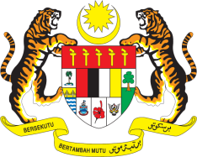

STATEMENT BY MALAYSIA
REVIEW OF SWITZERLAND
42ND SESSION OF THE UPR WORKING GROUP
23 JANUARY – 3 FEBRUARY 2023

Malaysia welcomes Switzerland’s commitments in fulfilling and monitoring its human rights obligations.

- In the spirit of constructive engagement, Malaysia recommends the following:

3.1 Consider to adopt a more comprehensive federal anti-discrimination law to combat racial discrimination, xenophobia, and related intolerance;

3.2 Consider to increase climate financing for developing countries and allocate new and additional funding for climate loss and damage;

3.3 Support efforts to realize equitable global access to COVID-19 health technologies through pooling of knowledge, intellectual property and data; and

3.4 Ensure that all refugees fleeing violence and persecution are afforded the same treatment, access and protection regardless of their nationality, ethnicity or religion.

- We wish Switzerland a successful review.

Thank you.

27 JANUARY 2023
GENEVA

