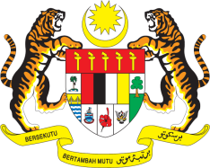

STATEMENT BY MALAYSIA
REVIEW OF THE REPUBLIC OF KOREA
42ND SESSION OF THE UPR WORKING GROUP
23 JANUARY – 3 FEBRUARY 2023

Malaysia thanks the Republic of Korea for its report.

- Malaysia welcomes the Republic of Korea’s efforts in strengthening the cohesiveness of its national policies to protect human rights and we encourage the Republic to continue its measures to protect vulnerable groups, address social inequality, provide affordable education and guarantee basic medical services.

- In the spirit of constructive engagement, Malaysia recommends the following:

3.1 Support parents by reducing the burden of childbirth and childcare expenses;

3.2 Implement the necessary reforms to reduce greenhouse gas emissions and to mitigate threats against human rights resulting from climate change, including through raising the NDC target consistent with human rights obligations; and

3.3 Promote gender equality by eliminating the drivers of discrimination against women and increasing women’s participation in the public and private sectors.

- We wish the Republic of Korea a successful review.

Thank you.

26 JANUARY 2023
GENEVA

