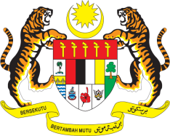

STATEMENT BY MALAYSIA
REVIEW OF BENIN
42ND SESSION OF THE UPR WORKING GROUP
23 JANUARY – 3 FEBRUARY 2023

Malaysia welcomes Benin’s commitments in undertaking inclusive and transparent reforms to strengthen human rights. We encourage Benin to improve the economic, social and cultural rights, including by increasing access to public services for its peoples.

- In the spirit of constructive engagement, Malaysia recommends the following:

3.1 Redouble efforts to protect women and girls from gender-based violence including through strengthening the detection of cases, reporting, investigation, and law enforcement;

3.2 Step up efforts to increase investment in agriculture in order to achieve food security so that vulnerable groups including children are free from hunger and chronic malnutrition; and

3.3 Improve the living conditions and standards of vulnerable populations by increasing their access to basic social protection services as well as sustainable and equitable economic opportunities.

- We wish Benin a successful review.

Thank you.

26 JANUARY 2023
GENEVA

