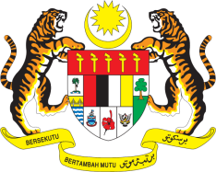

STATEMENT BY MALAYSIA
REVIEW OF GUATEMALA
42ND SESSION OF THE UPR WORKING GROUP
23 JANUARY – 3 FEBRUARY 2023

Malaysia thanks Guatemala for its report.

- Malaysia welcomes Guatemala’s commitments to promote and protect human rights through the establishment of the Presidential Commission for Peace and Human Rights in 2020. We encourage Guatemala to continue taking measures to uphold the rights of specific populations, namely women, children, older persons, persons with disabilities, indigenous peoples and migrants.

- In the spirit of constructive engagement, Malaysia recommends the following:

3.1 Continue its consultations with Indigenous communities in decision-making processes which concern them, and promote their right to education, sanitation, property and public positions;

3.2 Step up the implementation of the National Climate Change Action Plan and adopt measures to reduce greenhouse gas emissions; and

3.3 Take measures to improve the representation of women in decision-making positions, promote equal representation of men and women in public office, and reduce the gender pay gap.

- We wish Guatemala a successful review.

Thank you.

25 JANUARY 2023
GENEVA

