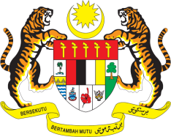

STATEMENT BY MALAYSIA
REVIEW OF GHANA
42ND SESSION OF THE UPR WORKING GROUP
23 JANUARY – 3 FEBRUARY 2023

Malaysia welcomes Ghana’s commitment to implement a human rights-based approach in development and governance, especially in the areas of health, education, food and water security, housing, environmental preservation, and respect for culture.

- In the spirit of constructive engagement, Malaysia recommends the following:

3.1 Ensure the access of sexual and reproductive health services for all vulnerable groups, including persons with disabilities;

3.2 Strengthen the national healthcare system by ensuring adequate funding and infrastructure, and improve people’s access to healthcare services by removing financial and transport barriers;

3.3 Adopt and implement human rights-consistent adaptation and disaster risk reduction measures in order to protect the population from the impacts of climate crisis, including food insecurity; and

3.4 Continue to strengthen legislation and institutions related to the elimination of human trafficking.

- We wish Ghana a successful review.

Thank you.

24 JANUARY 2023
GENEVA

