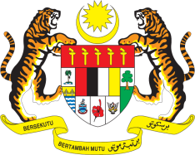

STATEMENT BY MALAYSIA
REVIEW OF GABON
42ND SESSION OF THE UPR WORKING GROUP
23 JANUARY – 3 FEBRUARY 2023

Malaysia commends Gabon for its commitments on human rights in various areas, as reflected in the reform of its institutional framework and Constitution. We welcome comprehensive efforts made by the government of Gabon to address the rights of women and to support gender equality. We are encouraged by Gabon’s efforts in empowering girls by ensuring access to education.

- In the spirit of constructive engagement, Malaysia recommends the following:

3.1 Continue taking steps to ensure inclusive education, especially for persons with disabilities;

3.2 Expedite the implementation of the Integrated Drinking Water Supply and Sanitation Programmes in Greater Libreville and the Access to Basic Services in Rural Areas Project to ensure adequate access to basic amenities with a view to improving the living conditions of the population; and

3.2 Continue efforts to ensure the operationalisation of the National Commission on Human Rights, in accordance with the Paris Principles.

- We wish Gabon a successful review.

Thank you.

24 JANUARY 2023
GENEVA

