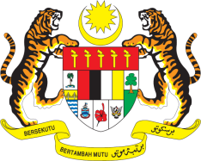

STATEMENT BY MALAYSIA
REVIEW OF ARGENTINA
42ND SESSION OF THE UPR WORKING GROUP
23 JANUARY – 3 FEBRUARY 2023

Malaysia commends Argentina on its strong commitment to advance women’s rights and tackle gender-based violence. We also encourage Argentina to continue working inclusively to protect the rights of persons with disabilities.

- In the spirit of constructive engagement, Malaysia recommends the following:

3.1 Continue to intensify efforts to strengthen its policies and strategies aimed at addressing human trafficking and exploitation;

3.2 Continue strengthening its policies and actions aimed at eradicating poverty and reducing inequalities to ensure that access to economic and social well-being assistance is guaranteed for the entire population;

3.3 Step up efforts to address cases of child food insecurity and malnutrition, as well as regularly monitor and assess the effectiveness of policies and programmes, including school meal programmes;

3.4 Continue to protect the rights of indigenous people to prevent discrimination and racism against indigenous communities especially women and children.

- We wish Argentina a successful review.

Thank you.

23 JANUARY 2023
GENEVA

